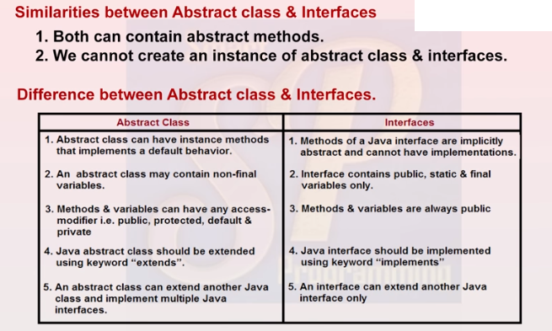

1.
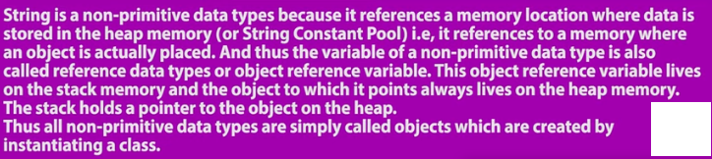
2. 

3. syntax : String IS A CLASS ,char sequence ,serilizable and comparable is an interface
Public final class String extends object implements charsequence,serilizable,comparable
{

}


Method
4. string is an object

To create String there are 3 classes :
String
StringBuffer
StringBuilder

*SCP is a special memory location present in heap area which is used to store string literals.
* it is not applicable for GC as JVM internally creates reference variables for each string Literal object.
The Java string constant pool (SCP) is an area inside heap memory where Java stores literal string values. ... When a new variable is created and given a value (literal eg. Deepak) , Java checks to see if that exact value exists in the pool. If it does, that value is re-used for the new variable. If not, it creates a new literal string.

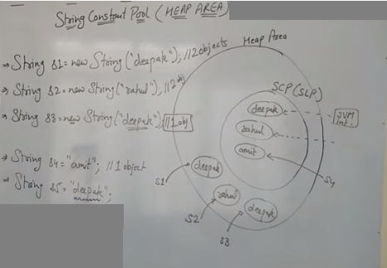
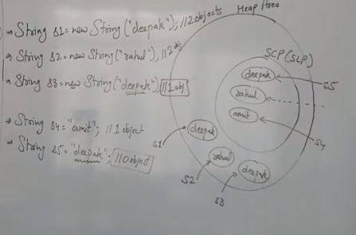

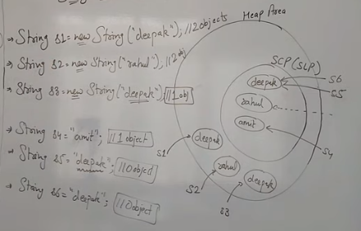

Why string objects are immutable in java

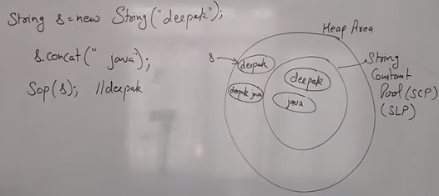

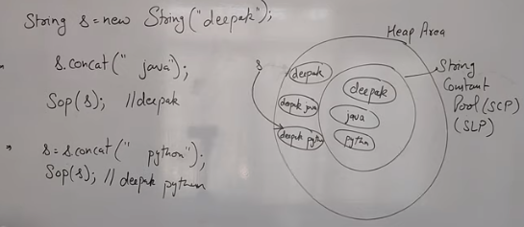

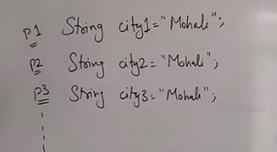
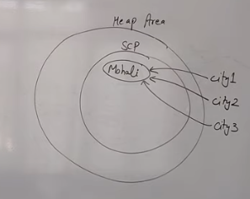
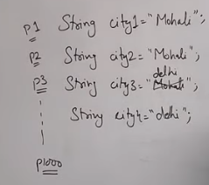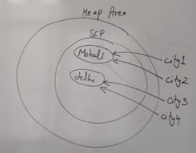
Because java uses the concept of string literal.Suppose there are 5 reference variables,allreferes to one object "sachin".If one reference variable changes the value of the object, it will be affected to all the reference variables. That is why string objects are immutable in java.
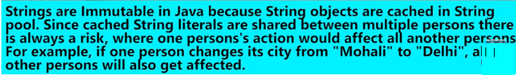
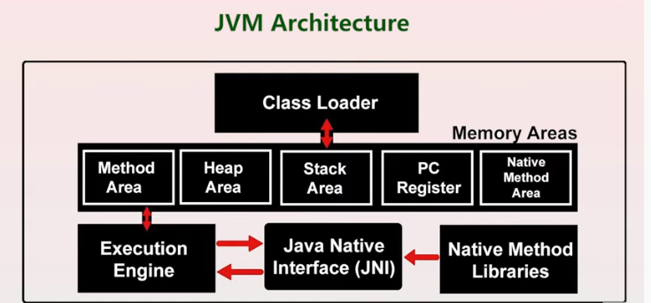
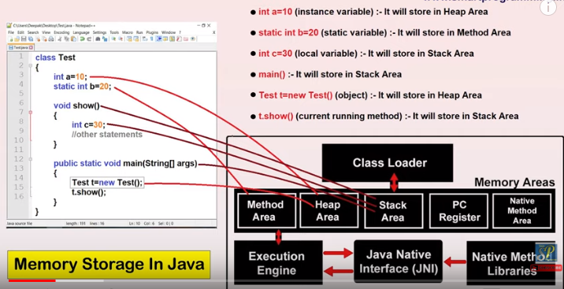

Stringbuffer is :
- More faster
- Less memory consumption
- 